How Ian Fleming started the Trafalgar Square Christmas tree tradition
The author of a new biography about the James Bond creator has unearthed the story of the first Norwegian tree gifted to Britain

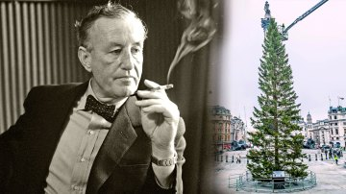
Fleming, who died in 1964, was unaware that his idea would become a regular event from 1947 onwards. Right: last year’s tree
The story of the Christmas tree in Trafalgar Square is well-rehearsed: it is a gesture of gratitude from Norway for Britain’s help during the Second World War.
What the official histories fail to record is that the tradition began on a drunken night out organised by the creator of James Bond.
A document discovered at the National Maritime Museum in Greenwich shows that Ian Fleming was not only present when the first Norwegian tree was placed in the central London square but suggested it.
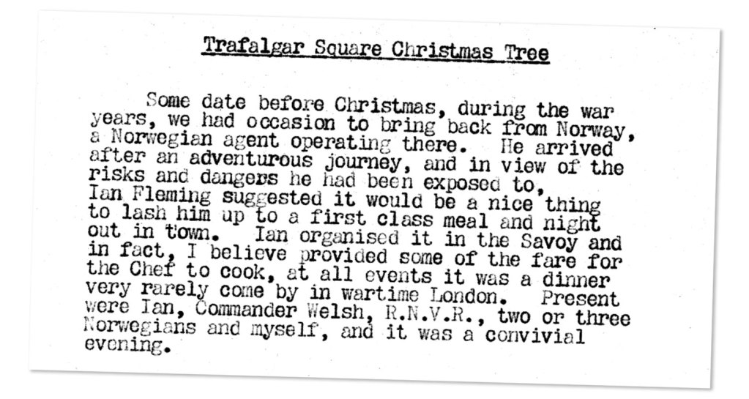
A typewritten note by Admiral Norman Denning, who became director of naval intelligence in the early 1960s, recalls a high-spirited evening out with Fleming in the winter of 1942.
Denning, who worked with Fleming in naval intelligence during the war, wrote that at “some date before Christmas, during the war years” the Royal Navy had brought back a Norwegian commando.
Advertisement
Although Denning does not name him, the agent was Mons Urangsvag, who returned from a raid on the island of Hisoy off the west coast of Norway with a pair of pine trees he cut down from an arboretum.
Traditional accounts of Urangsvag’s raid on Hisoy record him chopping down one tree as a gift for King Haakon VII of Norway, who had fled his home country after the invasion by Nazi Germany and was living in exile near Windsor. Those accounts have Uransvag delivering the tree to his king and the monarch asking for it to be placed in Trafalgar Square, without lights so as to comply with blackout conditions.
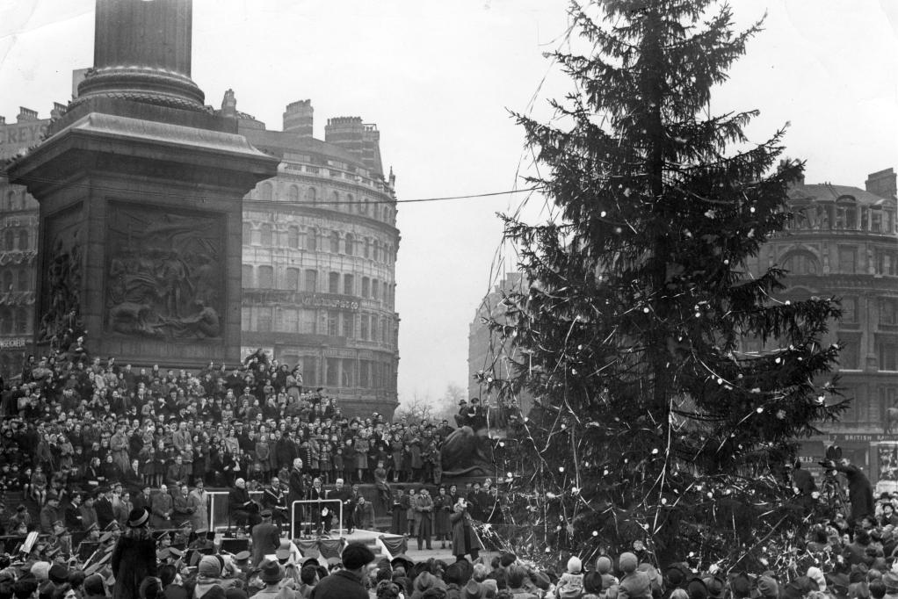
Crowds gathered to see the Christmas tree being handed over by the Norwegian ambassador in 1947
JACK BARKER FOR THE TIMES
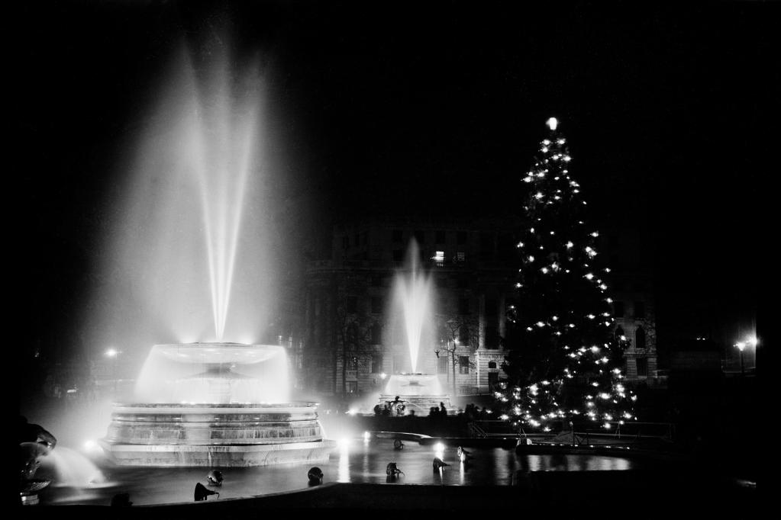
The tree is usually on display from the beginning of December until early January
ENGLISH HERITAGE/HERITAGE IMAGES/GETTY IMAGES
Denning’s version features two trees, one of which was tied to the square’s north balustrade before Haakon got sight of it.
He wrote that Urangsvag “arrived after an adventurous journey, and in view of the risks and dangers he had been exposed to, Ian Fleming suggested it would be a nice thing to lash him up to a first class meal and night out in town”.
Fleming not only arranged an evening at the Savoy but provided the kitchen with some ingredients that were scarce in wartime London.
Advertisement
“It was a convivial evening,” Denning wrote. “Afterwards we piled into two jeeps, only to discover that amongst the gear with the agent were two Christmas trees.” Denning believed that the trees had come from Haakon’s summer palace in Oslo rather than Hisoy.
“[He] smuggled [the trees] over with him at some discomfort, intending to present one to the King, then living at Sunningdale.
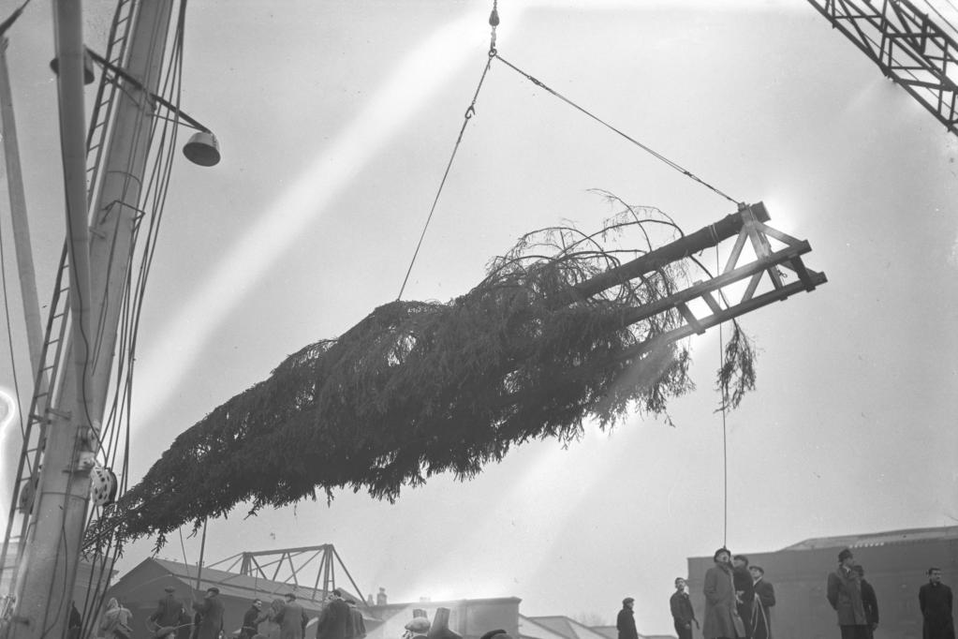
The tree reached Convoys Wharf in 1947 before being transported to the square
KEMSLEY NEWSPAPERS
“I think it was Ian who suggested that it would be a nice gesture to put up one in Trafalgar Square. This we did, tying it to a balustrade on the north side. Of course there were no fairy lights but one or two aircraft flares provided illumination.”
Denning’s note was unknown to historians until Nicholas Shakespeare, author of Ian Fleming: The Complete Man, asked the museum to search through its archive.
“It had always been the family’s belief [that Fleming had helped to set up the first Trafalgar Square tree] and they urged me to find out more. It was the last piece of original research I did: I pursued the Greenwich Maritime Museum and a keen researcher there produced Norman Denning’s memo.
Advertisement
“Denning worked with Fleming in naval intelligence and rose to become the penultimate director of naval intelligence. He can absolutely be trusted.” This year’s tree was cut down on Friday and is due to be installed with decorations by December 1.
Westminster Council, which looks after the tree when it is in situ, said that they had been unaware of Fleming’s involvement but would consider changing their history to include him.
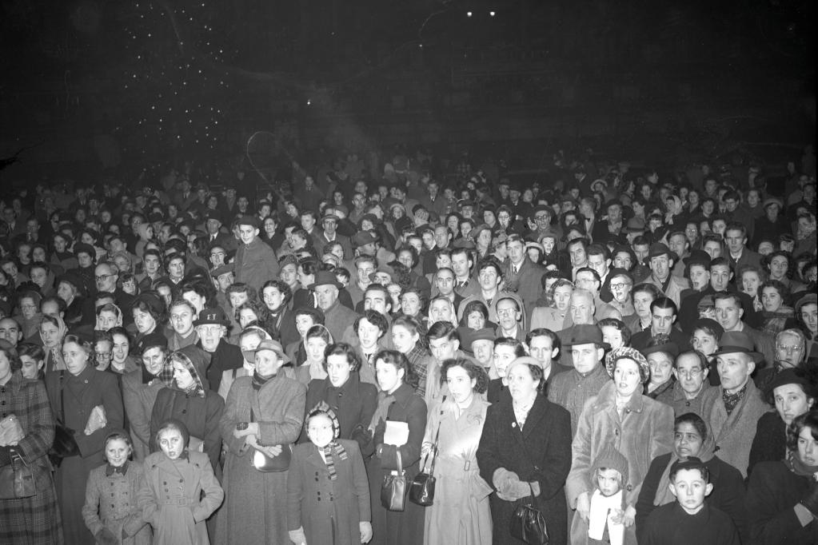
Crowds gathered to sing carols when the tree was lit up in 1950
KEMSLEY NEWSPAPERS
Fleming, who died in 1964, was unaware that his idea would become a regular event from 1947 onwards, with the Norwegian government sending a tree each year.
According to Denning, the future spy novelist was more animated by the drinks the Norwegian commando had brought with him.
“To us, more welcome perhaps was a bottle of Aquavit the agent had brought back with him. So passing the bottle from mouth to mouth, we toasted the happy return of the agent, King George, King Haakon and to the liberation of Norway.
Advertisement
“Even on this occasion Ian showed his bon viveur attitude with the remark ‘I’m not complaining, but nevertheless I still maintain Danish aquavit is the best’.”
Related articles

